Updating Existing Rules

Send rules will need to be changed pointing the replication files to the newly created mail accounts.
This will need to be done at the office for each vessel send rule.

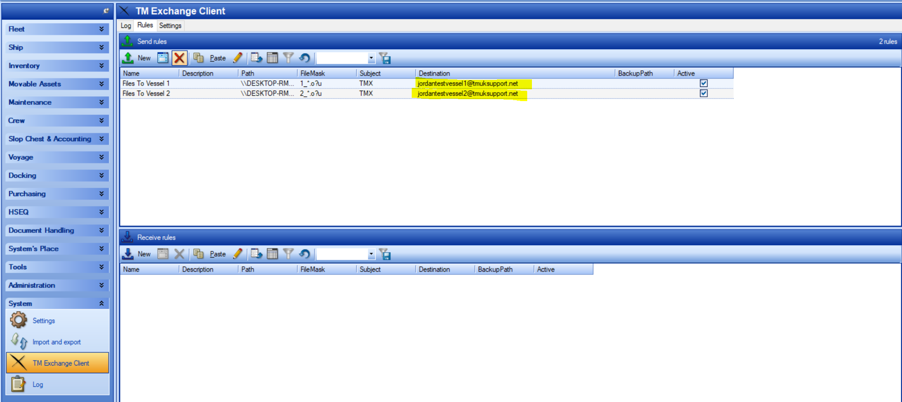

Each send rule on the vessel installations will also need to be updated to send replication files to the new office email account.
